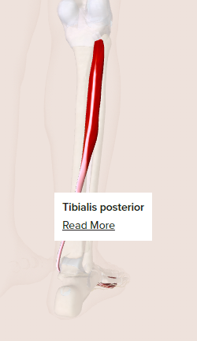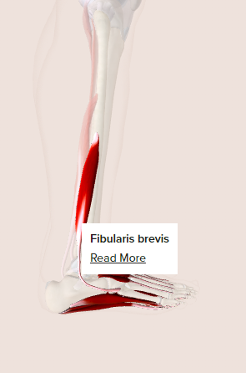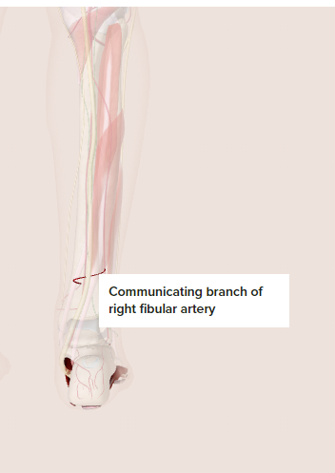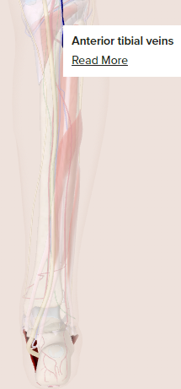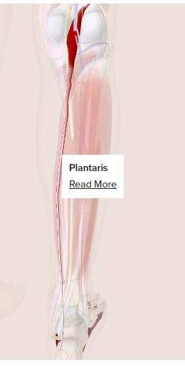

<https://www.healthline.com/human-body-maps/foot-muscles#1>